RESULTS OF THE
GRIFFON BRUXELLOIS BREEDERS ASSOCIATION
OPEN SHOW – 14TH FEBRUARY 2016
JUDGE: MR MARK COCOZZA

BD & BIS – CH MARQUANT THE HEART THROB
RBD – BEAUVIEW RAINING MEN
BB, BOS & RBIS – VENDETTAS TANGERINE BALTHAZAR
RBB – CH CILLEINE ANOTHER DAY
BPD - BALTHAZAR JOHNNY ANGEL
BPB & & BPIS - SHEVILAN EVERYBODY KNOWS ALICE
BVIS – CH GAYSTOCK JUST SO

Veteran Dog or Bitch (6,2a)
1. Ch Gaystock Just So
2. Ch Cilleine Imagine Sternroc
3, Aptrick Gilthoniel
4. Menwinnion Molinia

DOG CLASSES
2. Minor Puppy (3,1a)
1. Blacktsaar Marillion
2. Cilleine Remembrance at Glogriff

3. Puppy (3,1a)
1. Balthazar Johnny Angel BEST PUPPY DOG
2. Blacktsar Marillion
3. Feigusch Call Me Nicolaus at Osthaen
4. Cilleine Remembrance at Glogriff

4. Junior ((3,1a)
1. Marquant The Lover
2. Beauborne Galileo

5. Novice (3)
1. Beauview Check Me Over
2. Blacktsar Marillion
3. Cilleine Remembrance at Glogriff

6. Post Graduate (,2a)
1. Beauborne Bet It’s Presley

7. Limit (2)
1. Blacktsar Albany Duke
2. Aptrick Stornbraver

8. Open 4,1a)
1. Ch Marquant The Heart Throb BD & BEST IN SHOW
2. Beaview Raining Men RES BEST DOG
3. Chandling Chambertin at Cilleine

BITCH CLASSES

9. Minor Puppy (2)
1. Shevilan Everybody Knows Alice BPB & BEST PUPPY IN SHOW
2. Balthazar Devil Woman

10. Puppy (1)
1. Sabai London Pride

11. Junior (5,2a)
1. Menwinnion Silk Sari to Chandling
2. Marquant Candy Crush Love
3. Beauview Thunder Thighs

12. Novice (2,1a)
1. Sabai London Pride

13. Post Graduate (5,1a)
1. Beauview Devil May Care
2. Harpersband Dressed To Kill At Balthazar
3. Sabai Love In A Mist
4. Aptrick Scilla

14. Limit (6,5a)
1. Vendettas Tangerine Balthazar (imp) BEST BITCH & RBIS

15. Open Bitch (5,1a)
1. Ch Cilleine Another Day RES BEST BITCH

16. Sp Open Red – no entries

17. Sp Open Black D or B (1)
1. Marquant Media Storm

18. Sp Open Black & Tan D or B (4,2a)
1. Beauview Raining Men
2. Beauview Thunder Thighs

19. Sp Open Beginners (1)
1. Sabai Love In A Mist

BD & BIS – CH MARQUANT THE HEART THROB

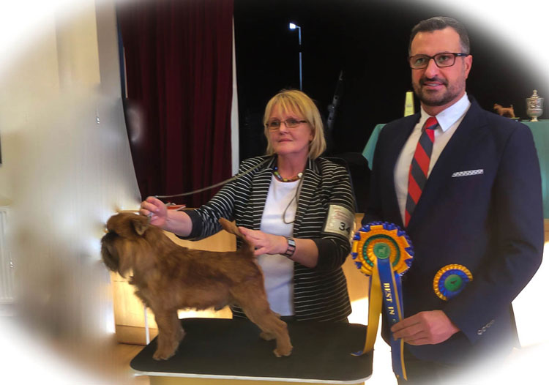

BB, BOS & RBIS – VENDETTAS TANGERINE BALTHAZAR

